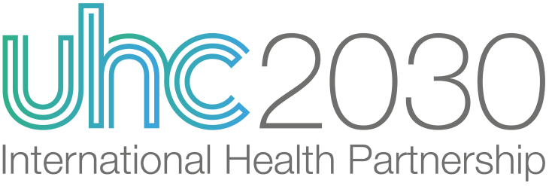 | UHC2030 Steering Committee  8th Session – 3 & 4 February 2021  Videoconference (Zoom)

Workplan and Budget 2021

For Information For Review & Advice For Approval

Workplan and Budget 2021
1. UHC2030 Strategic narrative and 2021 priorities
The COVID-19 pandemic has urgently reinforced why everyone, everywhere should have access to quality and affordable health services. To end this crisis and build a safer and healthier future, we must invest in health systems that protect us all — now.

This requires political commitment and collective action. UHC2030 has unique value as the multi-stakeholder platform to bring together diverse voices and perspectives for the common goal of achieving UHC, demand and track accountability for UHC commitments, and promote collective action for stronger health systems.

In 2019-2020 we:
- Galvanized political leadership for UHC, mobilized diverse voices to influence the UN Political Declaration on UHC, provided the first ever review of progress on political commitments (including a synthesis report and country profiles for all member states), and supported powerful global and country UHC Day campaigns;
- Promoted a shared vision for UHC and COVID-19, and action for stronger health systems to achieve UHC and health security goals;
- Elevated civil society voices and engagement, provided a platform for private sector contributions, and brought health systems networks and partnerships together for shared HSS learning.

Throughout the COVID-19 crisis, UHC2030 has made the case for sustained investments in health systems and universal access to health services. We have promoted specific actions towards both UHC and health security goals, based on the Key Asks of the UHC movement and political declaration commitments. As the world continues to respond to COVID-19, and considers how to ‘build back better’, these messages and actions are even more important. For example, questions about who gets to receive COVID-19 vaccination, within and across countries, are fundamentally questions about UHC.

IN 2021 WE WILL:
- Ensure UHC (including health systems and common goods for health) are prioritised in the COVID-19 response and ‘building back better’. We will be the global voice for “health systems that protect everyone”, take on barriers to political action identified in 2020’s groundbreaking ‘State of Commitment to UHC’ report, and develop high quality policy and learning products to promote collective action on health systems.
- Promote equitable access to vaccines as part of the UHC agenda. Our political advocacy and policy products will specifically address this urgent issue.
- Provide a “now to 2023 HLM” strategic vision for what the HLM outcomes should be and how UHC2030 contributes. We will again bring diverse voices together in the only multi-stakeholder review of countries’ progress towards UHC political commitments, streamline and promote an integrated approach to accountability for health goals (in partnership with PMNCH), and continue to foster the enabling environment for civil society and private sector contributions to UHC.

This is good value for money. UHC2030 offers funders an efficient and effective mechanism to support a unique shared platform and enabling environment. Base programme operating costs of $2.5m in 2021 are relatively small, with large potential returns in terms of leveraging political and financial commitments for health plus more coherent use of resources for health systems. To help demonstrate this value, in 2021 we will step up our tracking of influence and impact.

2. UHC2030 Results focus and logic

UHC2030 seeks collective action on the UHC Political Declaration commitments, based on the UHC Key Asks.

Our specific aim is that countries translate political commitments into meaningful action and results that can be demonstrated at the UN High Level Meeting on UHC in 2023 (SDGs mid-point). Our underlying rationale is that action by countries on political commitments, with more coherent involvement/support of all stakeholders, will contribute to stronger health systems and UHC plus health security outcomes:
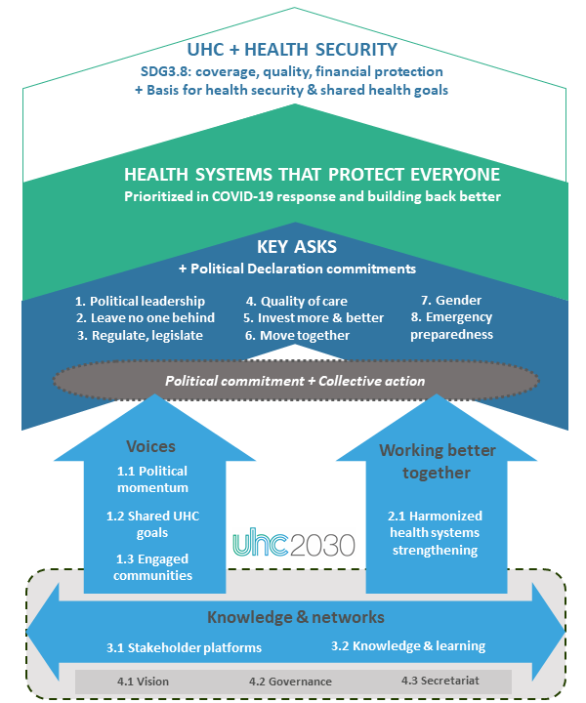

UHC2030’s work is therefore organized under three headings, ‘voices’, ‘working better together’, and ‘knowledge and networks’, with specific results areas and products for each of these. A fourth supporting work area includes governance and operations functions.
3. Workplan/products summary
Results Areas | 2021 Product lines | Sub-products / Activities
1.1 Political momentum | - State of UHC Commitment review | - Updated country profiles, + support for Voluntary National Reviews process  - 2021 synthesis / updated key messages  - UHC data portal promoted with partners [+ 3.2]
 | - Political advocacy statements and follow-up, including to prioritize UHC in pandemic response and building back better (UHC commitments, health systems and common goods for health) | - Political statements at key moments: G7, G20, WHA, UNGA, HLPF, Generation Equality Forum  - Briefings to New York and Geneva Missions  - Networks/collaboration with parliamentarians (IPU), local governments (UCLG), etc.  - UHC Political Advisors panel
1.2 Shared UHC goals | - Integrated accountability approach for UHC | - Streamlined annual tracking for UHC, PHC and Global Strategy for WCAH  - Synthesized evidence/information on accountability resources & tools  - Collaboration framework with PMNCH  - Joint strategy with health partnerships for 2023 HLM on UHC [+ 4.1]
 | - Campaign on “health systems that protect everyone”, including COVID-19 vaccine access and common goods for health as key elements of UHC | - Webinars & campaign messages for CSOs, building on UHC Day 2020  - Policy messages on vaccine access and UHC  - Blogs and thought leadership [+ 2.1.i, 3.1, 3.2]
1.3 Engaged communities | - Country advocacy/accountability package for health sector planning and budgeting, including priorities to ‘build back better’ | - Social Participation Handbook dissemination + country lesson-learning  - ‘UHC 101’ + guidance for country advocacy (CSEM)  - Collaborative learning agenda for CSO engagement in health financing, accountability and advocacy (with GHIs)
 | - UHC Day | - Campaign materials and coordination  - Events in collaboration with partners  - Grants TBC
2.1 Harmonised health systems strengthening | - “Health systems that protect everyone” investment case + shared policy agenda for HSS in pandemic response and recovery | - Joint policy statements on “case for investment” in health systems  - ODA study & follow-up: track aid for health systems and public health in collaboration with OECD/DAC  - Promote existing vision/principles (HSS Joint Vision, UHC & Emergencies Discussion Paper, 7 Behaviours)  - Blogs and thought leadership [+ 1.2.ii, 3.1, 3.2]
 | - Country UHC roadmaps and compacts | - Guided learning + manual for UHC roadmaps (with EMRO)  - Facilitate country compacts + learning where requested (potentially in collaboration with UHC Partnership, P4H, etc)
 | - Harmonised health systems policy guidance and tools, adapted to COVID-19 context and building back better | - Health systems performance assessment: finalise/launch framework & manual, document & share country learning  - Promote UHC2030 products/principles & country learning (sustainability & transition, PFM, fragile settings)
3.1 Stakeholder platforms | - Civil Society Engagement Mechanism | - Sustain platform  - Contributions to Output 1 products [& review alongside CSEM workplan]  - Strategy for CSO engagement to HLM 2023 [+ 1.2.i, 4.1.i]
 | - Private Sector Constituency | - Sustain platform, grow/diversify membership  - Discussion forums with civil society and government constituencies to build trust and mutual understanding  - Blogs & knowledge products demonstrate learning/action on HLM Statement on private sector contributions to UHC [+1.2.i, 3.2.ii]  - Strategy for private sector engagement to HLM 2023
 | - UHC2030 Related Initiatives (health systems networks, partnerships, collaboratives) | - Sustain collaboration platform, regular information-sharing  - Blog series + joint event on HSS contributions [+1.2.ii, 2.1.i]
3.2 Knowledge and learning | - UHC knowledge platforms and resources | - UHC data portal kept up-to-date [+1.1.i]  - TBC: respond to requests for UHC2030 involvement in G7 “Universal Knowledge Initiative” platform, G20 work on value-based healthcare, digital and future health systems  - Knowledge hub: home found
 | - UHC2030 thought leadership | - Timely and coherent blogs, briefs, etc [+ 1.2.ii, 2.1.i]
4.1 Vision | - “Now to 2023” vision | - Strategic plan of political process for 2023 HLM
4.2 Governance | - Strategic oversight | - Steering committee  - Resource mobilization strategy  - OECD/WB/WHO co-host arrangements formalized  - Updated learning/approach for defining and tracking influence/impact
4.3 Secretariat | - UHC2030 operations + reporting | - Core Team operations + Secretariat oversight (OECD/WB/WHO)  - Annual report; workplan & results updates  - Communications, website, social media

4. Indicative products for 2022-2023
Results areas | Indicative 2022-23 products
1.1 Political momentum | - Annual State of Commitment report and updated country profiles  - UN HLM 2023 multistakeholder engagement
1.2 Shared UHC goals | - Shared approach across health/disease partnerships for HLM 2023
1.3 Engaged communities | - Country advocacy/accountability package + learning  - UHC Day 2022, 2023  - Country level advocacy/mobilisation for UN HLM 2023
2.1 Harmonised health systems strengthening | - Provide platform for multi-stakeholder policy products in response to UHC2030 membership demands/needs (example: COVID-19 in Fragile Settings workshops and policy brief in 2020)  - Learning and facilitation support for roadmaps/compacts
3.1 Stakeholder platforms | - Constituencies to develop and agree priorities for future engagement and products, focused on HLM in 2023, with facilitation support from Core Team
3.2 Knowledge and learning | - Continue to provide platform/umbrella for HSS knowledge initiatives

5. Funding requirements for 2021 and current income situation

5.1 Budget 2021
The proposed budget for 2021 is USD 2.5 million (compared to USD 2.198 million expenditure in 2020). The proposed amount reflects costing based on 2020 expenditures and current ways of working (i.e. no in person meetings and limited travel). The proposed budget is broadly in line with the income that UHC2030 expects to mobilise in 2021 based on current indications of support.

See annex 1, for proposed 2021 budget.

5.2 Current funding situation

The current funding situation of UHC2030 looks more promising than 12 months ago, thanks to continued support from the EC and Japan, a new contribution from France and further support from WHO.
Total funding mobilized in 2020 was USD 4.47 million. However, a significant portion of 2021 funding (EU contribution) had to be brought forward to 2020 to cover a deficit at the beginning of the year, and a large proportion of new funding came very late in 2020 so is carried over for 2021 activities. There were sufficient resources for UHC2030 to implement its “base programme” in 2020.
Total expenditure in 2020 was USD 2.184 million – see annex 2, for detailed budget execution. Document UHC2030/SC8/2021/4.Rev1 summarises 2020 implementation and achievements delivered through this expenditure. Expenditure was USD 0.19 million above the base budget of USD 1.995 million. The State of Commitment review and UHC Day required slightly greater resources than budgeted. The Civil Society Engagement Mechanism had a slight underspend due to the cancellation of in-person meetings and travel, plus a saving against anticipated costs for new contractual arrangements.
Following consolidation of accounts at the beginning of 2020, UHC2030 had a deficit of
USD 594 265 from 2019 workplan implementation (largely from support committed to the UN High Level Meeting). Further consolidation of accounts and another WHO contribution 2020
(USD 200 000) reduced the deficit to USD 44 265. In the meantime, UHC2030 had to borrow
USD 59 582 from WHO to cover staff costs until new financial contributions became available.

The costs of implementing UHC2030 workplan and supporting the joint UHC2030 Secretariat are incurred by WHO and the World Bank. Until the end of 2019, WHO transferred funds to the World Bank via a trust fund agreement between the two organizations. Modalities for covering support costs for each organization (and for OECD when its participation is formalized) and support for UHC2030 from the Secretariat co-hosting agencies, are being currently reviewed.
As well as direct funding contributions, in 2020 UHC2030 benefited from significant in kind support. This included support from WHO and the World Bank, who is now hosting private sector constituency. The Global Fund and the Global Financing Facility provided in-kind support to civil society engagement in health financing advocacy through a collaboration between UHC2030 and PMNCH.
Table 1 below provides an overview of sources of funding in 2021 and future year as well as a summary of previous years. These are sufficient to cover the costs needed to implement UHC2030’s workplan for 2021, based on the assumption that travel and in-person meetings will remain limited throughout the year.

Table 1 – Status of funding of UHC2030, 2020
Donors | 2019 | 2020 | 2021 | 2022
Carry forward  Of which: Germany Japan  France | 797 129  [544 926]  [252 203] | - 594 265 (1)  Further reduced to:  -244 265 | 2 292 732  [545 550]  [1 851 040]  [-103 858](4)
New contributions
European Commission(2) | 586 648 | 1 745 475 | 340 045 | 1 042 760
Japan | 1 027 068 | 776 468 | tbc
Luxembourg | 500 000 | -- | -- | --
WHO | 250 000 | 200 000(3) |  | --
France | -- | 2 000 000 | tbc
Others (tbc) | -- | --
Sub-total (5) | 2 363 716 | 4 721 943 | 340 045 | 1 042 760
Total | 3 160 845 | 4 477 678 | 2 632 777
For ref: expenditure (6) | 3 755 110 | 2 184 936 | -- | --

Notes:
- This amount needs to be reimbursed to WHO in 2020 and/or 2021. This deficit was reduced in 2020 following agreement with WHO not to charge back costs of staff loaned to UHC2030 for the preparation of the HLM in 2019. The outstanding deficit amounts currently to USD 44 265.
- In 2020, we had to use some of the allocation for 2021 of the EC award due to the availability of funding from Japan and France in November 2020.
- This amount is a contribution from WHO in early 2021 to absorb some of the deficit in 2019.
- This amount corresponds to the outstanding debt of UHC2030 towards WHO: including USD 44 265 (outstanding deficit in 2019) and USD 59 582 (borrowing in 2020 to compensate for late arrival of new financial contributions).
- Amounts are net of programme support costs – and reflect accounts as of mid January 2020 (subject to further consolidation).
- Situation as of 20 January, subject to further consolidation of accounts.

  - Way forward

The Core Team mobilized in the first part of 2020 a task team on resource mobilisation, which brought one representative from each constituency and worked closely with the Core Team to address collectively the challenge of funding. In June, the task team presented to the Steering Committee a plan to address immediate funding needs, while the development of a longer term strategy would require more in-depth ground work. The short term plan included critical elements of UHC2030 unique value proposition and principles for a collective responsibility of the Steering Committee to approach resource mobilization.
The Steering Committee recommended to develop the “case for support”, a brief document that frames the value proposition of UHC2030 that everyone can use to reach out to potential donors and to follow-up with constituencies whose members with an interest to consider financial support.
In the meantime, the Secretariat has mobilized a new contribution from the French government and will follow-up with different constituencies on communications with a range of partners. The Secretariat will also focus on developing a longer-term resource mobilization strategy in 2021 and proposes to reengage with the task team on resource mobilization for this purpose.
Annex 1 – 2021 budget
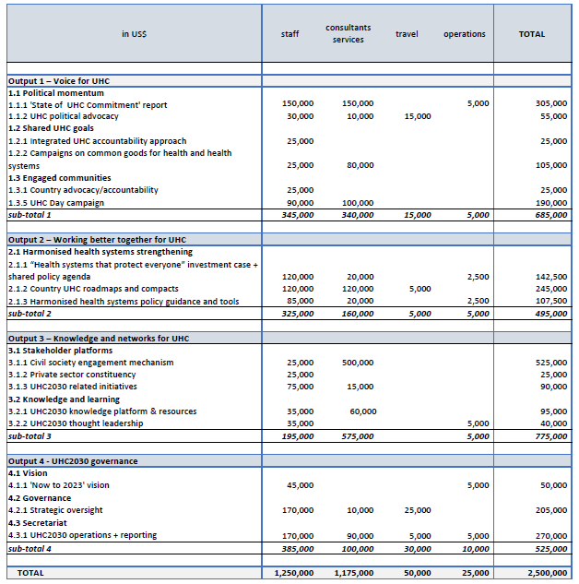
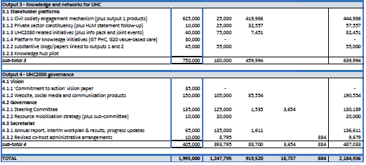
Annex 2 – Detailed 2020 budget execution

