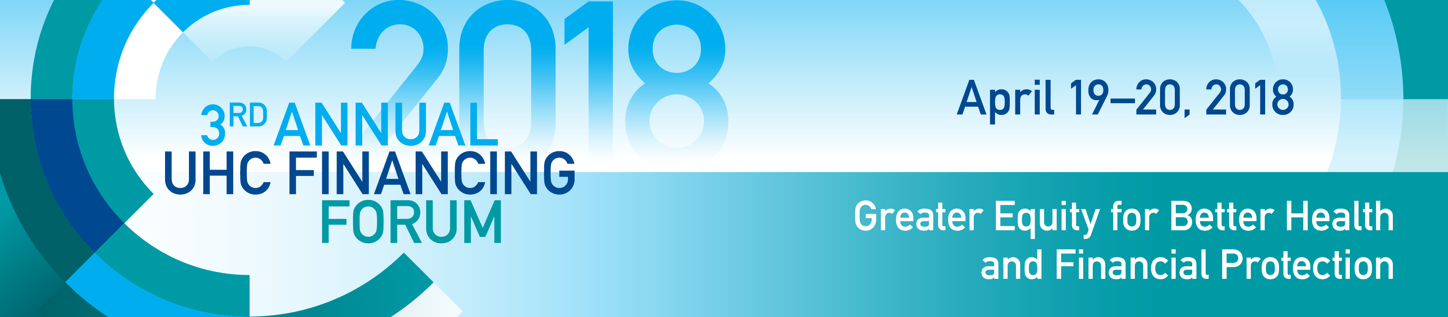

PFM IN HEALTH SATELLITE SESSIONS
ANNUAL UHC FINANCING FORUM

Wednesday, April 18: Washington Hilton Hotel, 1919 Connecticut Ave NW
8:30 – 10:00 | SATELLITE SESSIONS 1 : Washington Hilton Hotel, 1919 Connecticut Ave NW
Columbia 8 | What makes a good case for increased budget allocation to the health sector?  Chair:  - Jim Brumby; Director, Governance Global Practice, World Bank  Panelists:  - Hon. Kwaku Agyemang-Manu, Minister of Health, Ghana  - Mr. Ben Akabueze, Director General of Budget, Federal Ministry of Budget and National Planning, Nigeria  - Mr. Kazuhiko Koguchi, Executive Director, World Bank  - Dave Coady, Deputy Division Chief, Expenditure Policy Division, Fiscal Affairs Department, IMF  Closing remarks:  - Tim Evans, Senior Director, Health Nutrition and Population Global Practice, World Bank  Abstract: The session will discuss the institutions, processes, capacities and information that are required to support the case for increased allocation to health within and outside the ministry of health. Each of the panelists will be asked to expand on their roles and share their experience on the mechanisms and approaches that worked or did not work in making the case for increasing health spending. They will also be asked to identify key challenges in terms of these mechanisms and resources that in their experience constrain effectiveness making the case for increased allocation to health.
10:45 – 12:15 | SESSION 2 - SESSION AT THE PALOMAR HOTEL 2121 P St NW, Washington, DC 20037
Palomar Hotel,  National Ballroom | Public financial management in health: how can planning and budgeting support health sector objectives?  Moderators:  - Manoj Jain, Lead Financial Management Specialist, Governance Global Practice, World Bank  - Tekabe Belay, Program Leader, Human Development, World Bank  Presentation by:  - David Wachira, Public Sector Specialist, World Bank  - Vibhuti Hate, Consultant, World Bank  - Mustapha Babak, Consultant, World Bank  Abstract: In this session, the World Bank will share and receive feedback on the first part of the public financial management (PFM) in health tool that links PFM drivers to health financing (HF) objectives, and demonstrate how the tool may be applied.  An open and orderly PFM system enables (i) aggregate fiscal discipline, (ii) strategic allocation of resources, and (iii) efficient service delivery. Similarly, an effective health financing system is expected to assure funding (i) adequacy from domestic sources, (ii) predictability, (iii) efficiency, (iv)transparency and accountability, and (v)equity.  Consequently, meaningful progress towards Universal Health Coverage (UHC) will require not only harnessing the developmental linkages between PFM and HF but also aligning them even closer to maximize impact.
6:30-8:00PM | SATELLITE SESSION 3: Washington Hilton Hotel, 1919 Connecticut Ave NW
Columbia 6 | Activity based Budgeting versus program based budgeting: Which is better for the health sector?  Moderator:  - Hisham Waly, Practice Manager, Governance Global Practice, World Bank  Panelists:  - Joseph Kutzin, Coordinator, Health Financing, World Health Organization, Switzerland  - Manoj Jain, Lead Financial Management Specialist, World Bank  - Philipp Clause, Program Manager, Bill and Melinda Gates Foundation  - Bryn Welham, Senior Research Fellow, Overseas Development Institute, UK  - Pak Pungkas Ali, Ministry of National Planning, Indonesia  Closing Remarks:  - Renaud Seligmann, Practice Manager, Governance Global Practice, World Bank  Abstract: Program based-budgeting (PBB) supposedly enhances health service delivery results because it affords greater predictability in funds flow and flexibility in the use of funds. As a result, most health financing reforms focusing on results-based financing -in low to lower middle-income countries- have championed program-based budgeting as the preferred form of budgeting for the sector.  However, viewed from a PFM lens, a fundamental question to address is whether or not activity-based budgeting is the real villain of unpredictable funds flow and inflexible use of funds in the health sector (and other sectors)?  Panelists will debate the issue, supporting their positions with country examples and professional experiences.

